K. SAI KUMAR
192372080
CSA4308
LAB EXPERIMENTS

16) PROGRAM
<!DOCTYPE html>
<html>
<head>
<title>ComplaintEase</title>

<style>
body {
font-family: Arial;
background-color: #f2f2f2;
margin: 0;
}

header {
background-color: #333;
color: white;
text-align: center;
padding: 20px;
}

nav {
background-color: #555;
text-align: center;
padding: 10px;
}

nav a {
color: white;
text-decoration: none;
margin: 15px;
}

.container {
width: 80%;
margin: 30px auto;
background-color: white;
padding: 20px;
}

h2 {
color: #333;
}

input, textarea, select {
width: 100%;
padding: 10px;
margin: 8px 0;
}

button {
background-color: #333;
color: white;
padding: 10px 20px;
border: none;
}

.box {
border: 1px solid #ccc;
padding: 15px;
margin-top: 20px;
}
</style>
</head>

<body>

<header>
<h1>ComplaintEase</h1>
<p>Online Complaint Registration and Management System</p>
</header>

<nav>
<a href="#">Home</a>
<a href="#">Login</a>
<a href="#">Register</a>
<a href="#">Post Complaint</a>
<a href="#">Status</a>
<a href="#">Feedback</a>
</nav>

<div class="container">

<h2>Register Complaint</h2>

<form>
<label>Name:</label>
<input type="text" placeholder="Enter your name">

<label>Email:</label>
<input type="email" placeholder="Enter your email">

<label>Complaint Category:</label>
<select>
<option>Select Category</option>
<option>Road</option>
<option>Water</option>
<option>Electricity</option>
<option>Garbage</option>
<option>Other</option>
</select>

<label>Complaint Description:</label>
<textarea rows="5" placeholder="Enter your complaint"></textarea>

<label>Location:</label>
<input type="text" placeholder="Enter location">

<label>Upload Proof:</label>
<input type="file">

<button type="submit">Submit Complaint</button>
</form>

<div class="box">
<h2>Check Complaint Status</h2>

<label>Complaint ID:</label>
<input type="text" placeholder="Enter complaint ID">

<button>Check Status</button>
</div>

<div class="box">
<h2>User Features</h2>
<ul>
<li>Login</li>
<li>Register</li>
<li>Post Complaint</li>
<li>Location Mark in Google Map</li>
<li>View Complaint Status</li>
<li>Give Feedback</li>
<li>Get Admin Contact Details</li>
</ul>
</div>

<div class="box">
<h2>Officer Features</h2>
<ul>
<li>Register and Login</li>
<li>View Complaint</li>
<li>Update Complaint Status</li>
<li>Upload Proof of Work</li>
</ul>
</div>

<div class="box">
<h2>Admin Features</h2>
<ul>
<li>Generate ID and Password for Officer</li>
<li>Create / Delete Account</li>
<li>View Accounts</li>
<li>Change Password</li>
<li>Hide Features</li>
<li>Insert OES Information</li>
<li>Access Officer Accounts</li>
</ul>
</div>

</div>

</body>
</html>
0UTPUT:
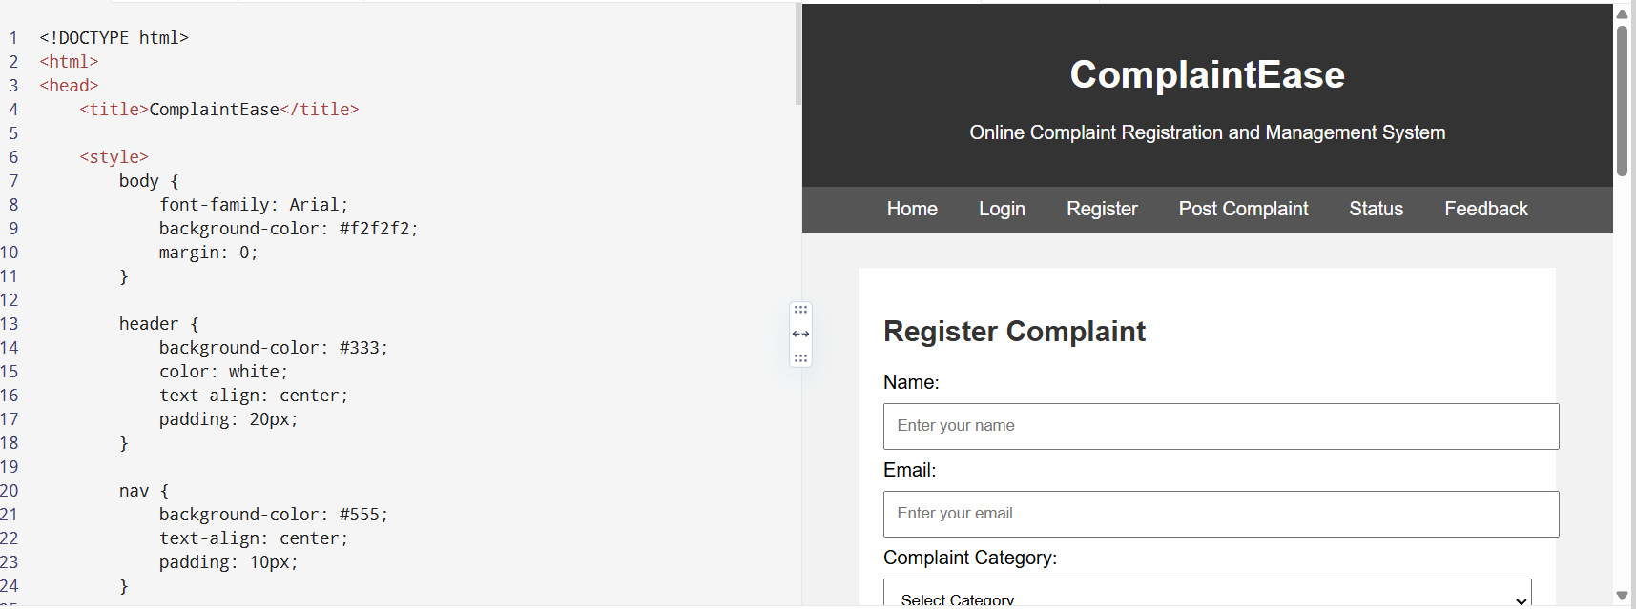

17)PROGRAM
<!DOCTYPE html>
<html>
<head>
<title>VoteOnline</title>

<style>
body {
font-family: Arial;
background-color: #f2f2f2;
}

h1 {
background-color: #333;
color: white;
text-align: center;
padding: 20px;
}

.box {
background-color: white;
width: 80%;
margin: 20px auto;
padding: 20px;
border: 1px solid #ccc;
}

input, select {
width: 90%;
padding: 10px;
margin: 8px;
}

button {
background-color: #333;
color: white;
padding: 10px 20px;
border: none;
margin: 5px;
}

a {
margin: 15px;
color: blue;
}
</style>
</head>

<body>

<h1>VoteOnline</h1>

<div class="box">
<a href="#">Home</a>
<a href="#">Admin</a>
<a href="#">Voter Login</a>
<a href="#">Results</a>
</div>

<!-- Admin Section -->
<div class="box">
<h2>Admin</h2>

<h3>Create Election Candidate</h3>
<input type="text" placeholder="Candidate Name">
<input type="text" placeholder="Election Name">
<button>Create Candidate</button>

<h3>Voter Management</h3>
<button>Create Voter List</button>
<button>Import Voter List</button>
<button>View / Update Voter List</button>

<h3>Election</h3>
<button>Allocate Election Data</button>
<button>Allocate User to Election Ward</button>

<h3>Results</h3>
<button>Get Election Results</button>
</div>

<!-- Voter Section -->
<div class="box">
<h2>Voter</h2>

<label>Voter ID:</label>
<input type="text" placeholder="Enter Voter ID">

<button>Login</button>

<h3>OTP Verification</h3>
<input type="text" placeholder="Enter OTP">
<button>Verify OTP</button>

<h3>Voting</h3>
<button>Get OTP for Voting</button>

<br><br>

<label>Select Candidate:</label>
<select>
<option>Select Candidate</option>
<option>Candidate 1</option>
<option>Candidate 2</option>
<option>Candidate 3</option>
</select>

<br>

<button>Submit Vote</button>
</div>

<!-- Voting History -->
<div class="box">
<h2>Voting Information</h2>

<ul>
<li>View Voting History</li>
<li>Vote Confirmation</li>
<li>Track Election Progress</li>
<li>Secure Voter Information</li>
</ul>
</div>

</body>
</html>
OUTPUT:
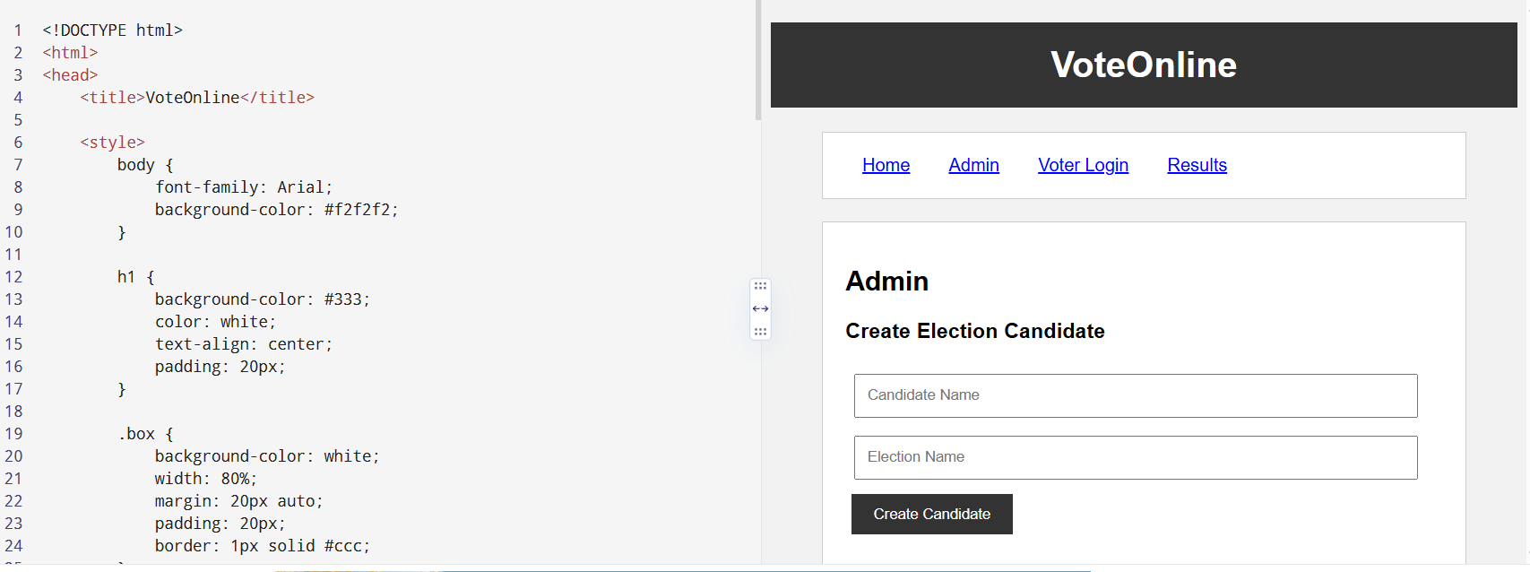

18)PROGRAM
<!DOCTYPE html>
<html>
<head>
<title>AgriMart</title>

<style>
body {
font-family: Arial;
background-color: #f2f2f2;
}

h1 {
background-color: green;
color: white;
text-align: center;
padding: 20px;
}

.box {
background-color: white;
width: 80%;
margin: 20px auto;
padding: 20px;
border: 1px solid #ccc;
}

input, select {
width: 90%;
padding: 10px;
margin: 5px;
}

button {
background-color: green;
color: white;
padding: 10px 20px;
border: none;
margin: 5px;
}

a {
margin: 15px;
color: green;
}
</style>
</head>

<body>

<h1>AgriMart</h1>

<div class="box">
<a href="#">Home</a>
<a href="#">Farmer</a>
<a href="#">Public</a>
<a href="#">Products</a>
<a href="#">My Orders</a>
<a href="#">Logout</a>
</div>

<!-- Farmer Section -->
<div class="box">

<h2>Farmer</h2>

<h3>Login</h3>
<input type="text" placeholder="Enter Username">
<input type="password" placeholder="Enter Password">
<button>Login</button>

<h3>Register</h3>
<input type="text" placeholder="Farmer Name">
<input type="email" placeholder="Email">
<input type="text" placeholder="Mobile Number">
<button>Register</button>

<h3>OTP Verification</h3>
<input type="text" placeholder="Enter OTP">
<button>Verify OTP</button>

<h3>Product Management</h3>
<button>Add Product</button>
<button>Update Product</button>
<button>Delete Product</button>
<button>Upload Images</button>

<h3>Orders</h3>
<button>Manage Orders</button>
<button>Update Order Status</button>
<button>Update Shipping Status</button>

<h3>Sales</h3>
<button>View My Sales</button>

</div>

<!-- Public Section -->
<div class="box">

<h2>Public / Customer</h2>

<h3>Register</h3>
<input type="text" placeholder="Name">
<input type="email" placeholder="Email">
<input type="password" placeholder="Password">
<button>Register</button>

<h3>Login</h3>
<input type="text" placeholder="Username">
<input type="password" placeholder="Password">
<button>Login</button>

<h3>OTP Verification</h3>
<input type="text" placeholder="Enter OTP">
<button>Verify OTP</button>

<h3>Search Product</h3>
<input type="text" placeholder="Search seeds, fertilizers, tools...">
<button>Search</button>

<h3>Products</h3>

<select>
<option>Select Category</option>
<option>Seeds</option>
<option>Fertilizers</option>
<option>Pesticides</option>
<option>Farming Equipment</option>
<option>Tools</option>
</select>

<br>

<button>View Product Details</button>
<button>Add to Cart</button>

<h3>My Account</h3>
<button>Manage Wallet Balance</button>
<button>View My Orders</button>

<h3>Shopping Cart</h3>
<button>Edit Cart</button>
<button>Delete Cart</button>

<h3>Shipping</h3>
<button>Add Shipping Address</button>
<button>Edit Shipping Address</button>
<button>View Shipping Status</button>

</div>

<!-- Product List -->
<div class="box">

<h2>Available Products</h2>

<ul>
<li>Seeds - ₹500</li>
<li>Fertilizers - ₹800</li>
<li>Pesticides - ₹600</li>
<li>Farming Equipment - ₹2000</li>
<li>Agricultural Tools - ₹1000</li>
</ul>

</div>

</body>
</html>
OUTPUT:
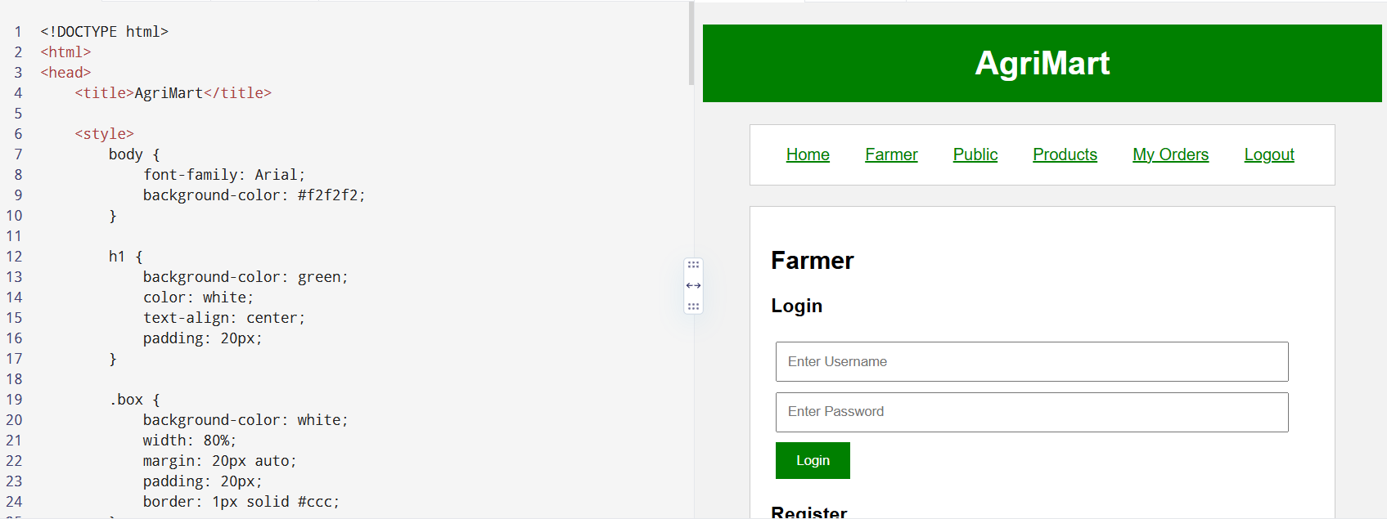

19)PROGRAM
<!DOCTYPE html>
<html>
<head>
<title>Animal Disease Management System</title>
</head>

<body>

<h1>Animal Disease Management System</h1>

<h2>Project Description</h2>

<p>
The farmer can send animal signs and symptoms to the doctor
using video, audio, images or text. The doctor can receive the
farmer's request and provide a solution. Farmers can register,
make payments and view doctors and reports.
</p>

<h2>User Module</h2>

<ul>
<li>Register</li>
<li>Login</li>
<li>Post Complaint</li>
<li>My Complaint Status</li>
<li>View Lecture Details</li>
<li>View News</li>
<li>View Doctor</li>
<li>View Report</li>
<li>Post Feedback</li>
<li>Make Payment</li>
<li>My Profile</li>
</ul>

<h2>Doctor Module</h2>

<ul>
<li>Register</li>
<li>Login</li>
<li>View Complaint</li>
<li>Post Solution</li>
<li>Manage Cure</li>
<li>Manage News</li>
<li>View User Details</li>
<li>View Payment Details</li>
<li>Feedback Details</li>
</ul>

</body>
</html>
OUTPUT:
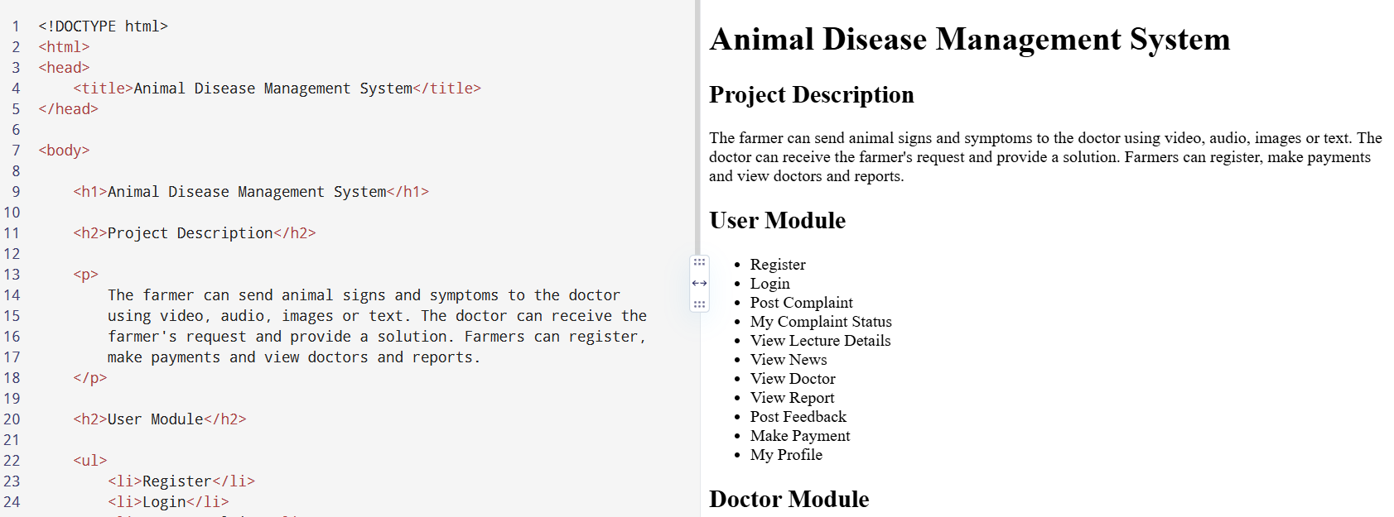
20)PROGRAM
<!DOCTYPE html>
<html>
<head>
<title>RentRide - Vehicle Rental</title>

<style>
body {
font-family: Arial;
margin: 0;
background-color: #f2f2f2;
}

header {
background-color: #222;
color: white;
text-align: center;
padding: 20px;
}

nav {
background-color: #444;
text-align: center;
padding: 10px;
}

nav a {
color: white;
text-decoration: none;
margin: 20px;
}

.container {
width: 80%;
margin: 20px auto;
}

.box {
background-color: white;
padding: 20px;
margin-bottom: 20px;
border-radius: 10px;
}

input, select {
width: 90%;
padding: 10px;
margin: 8px;
}

button {
background-color: #222;
color: white;
padding: 10px 20px;
border: none;
cursor: pointer;
}

footer {
background-color: #222;
color: white;
text-align: center;
padding: 15px;
}
</style>
</head>

<body>

<header>
<h1>RentRide</h1>
<p>Easy and Convenient Vehicle Rental</p>
</header>

<nav>
<a href="#home">Home</a>
<a href="#search">Search</a>
<a href="#booking">Booking</a>
<a href="#admin">Admin</a>
<a href="#login">Login</a>
</nav>

<div class="container">

<!-- Search Module -->
<div class="box" id="search">
<h2>Search Vehicle</h2>

<label>Vehicle Type:</label>
<select>
<option>Car</option>
<option>Bike</option>
<option>Truck</option>
<option>SUV</option>
</select>

<label>Location:</label>
<input type="text" placeholder="Enter location">

<label>Rental Duration:</label>
<input type="text" placeholder="Enter duration">

<button>Search</button>
</div>

<!-- Vehicle Details -->
<div class="box">
<h2>Vehicle Details</h2>

<h3>Car</h3>
<p>Price: ₹1500 per day</p>
<p>Location: Chennai</p>

<button>Book Now</button>
</div>

<!-- User Registration -->
<div class="box" id="login">
<h2>User Registration</h2>

<input type="text" placeholder="Enter Name">
<input type="email" placeholder="Enter Email">
<input type="password" placeholder="Enter Password">

<button>Register</button>
</div>

<!-- Booking -->
<div class="box" id="booking">
<h2>Vehicle Booking</h2>

<input type="text" placeholder="Customer Name">
<input type="text" placeholder="Address">
<input type="text" placeholder="Vehicle Type">
<input type="date">

<button>Make Booking</button>
</div>

<!-- User Features -->
<div class="box">
<h2>User</h2>

<ul>
<li>Register</li>
<li>Login</li>
<li>Search Vehicle Details</li>
<li>Select Vehicle and Make Booking</li>
<li>View Booking Status</li>
<li>My Profile</li>
<li>Reviews</li>
</ul>
</div>

<!-- Admin Features -->
<div class="box" id="admin">
<h2>Admin</h2>

<ul>
<li>Admin Login</li>
<li>Add Vehicle</li>
<li>Manage Vehicle Details</li>
<li>Manage Booking Details</li>
<li>Approve User Booking</li>
</ul>
</div>

</div>

<footer>
<p>RentRide © 2026 | 24/7 Customer Support</p>
</footer>

</body>
</html>
OUTPUT:
